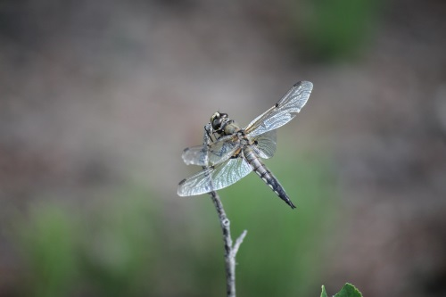

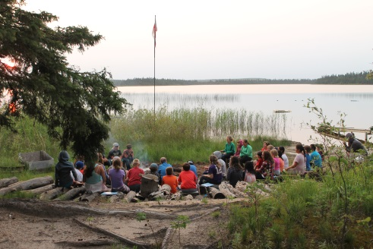
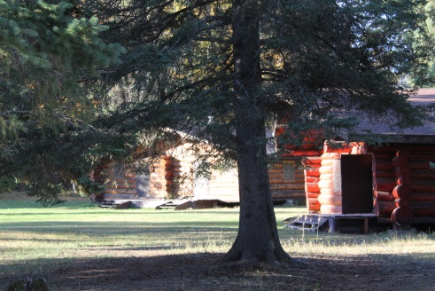
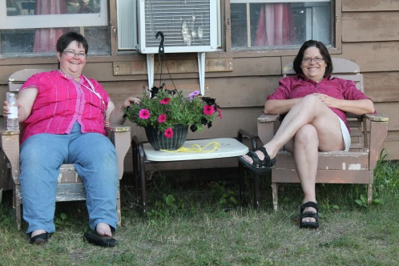

Okema Society Ladies Retreat
June 3-5
Please join us for a relaxing weekend of fellowship and fun.

Speaker: Candace Bacon, Moose Jaw
Ages 18+ $120

Agenda
Friday, June 3rd
6:00-8:00 Arrival and unpack
Charcuterie Board and Appetizers in Manna House
8:00 Introduction and Games
Devotional
Good Night Sleep

Saturday, June 4th
8:30-10:00 Continental Breakfast (
fruit, eggs, bagels, muffins, cheese, coffee tea etc)
10:30 Chapel and Bible Study
12:00 Lunch Soup and Salads
2:00-5:00 Craft/ Hike/ Canoe
6:00 Supper (Bake Potato, BBQ Chicken, Salads, Dessert)
7:30 Group Activity
8:30 Campfire and Devotional
Games, Visiting
Good Night Sleep

Sunday, June 5th
8:30- 10:00 Continental Breakfast
10:30 Chapel and Bible Study
12:00 Lunch
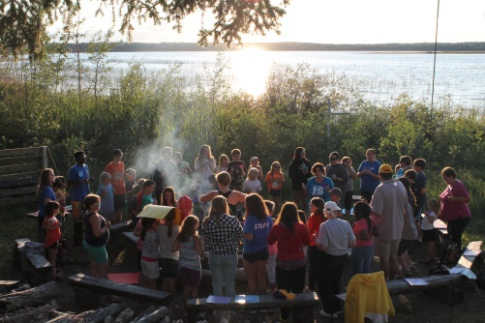
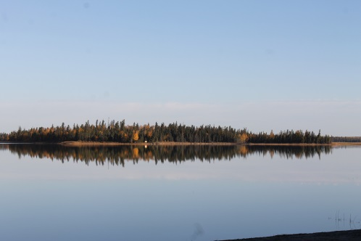
Safe travels home

